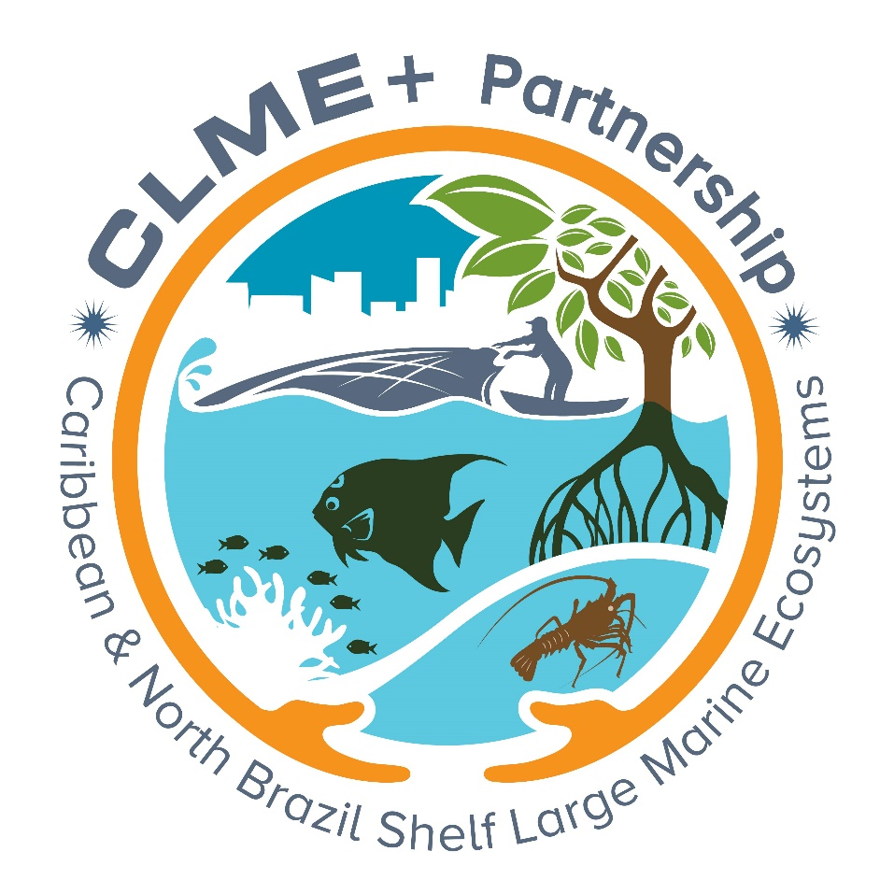

Terms of Reference (ToRs)

for the

GLOBAL PARTNERSHIP FOR THE SUSTAINABLE MANAGEMENT, USE AND PROTECTION OF THE CARIBBEAN AND NORTH BRAZIL SHELF
LARGE MARINE ECOSYSTEMS (CLME+ REGION)

THE “CLME+ PARTNERSHIP”

Contents

1. Purpose and Status of this Document 3
2. Nature of the CLME+ Partnership 3
3. Context and Justification 3
4. Definition 5
5. Vision and Goal 5
6. Mission 5
7. Specific Objectives 5
8. Thematic Scope 6
9. Geographic Scope 6
10. Structure and Governance 7
11. Membership 8
12. Guiding Principles for good marine resources governance and management 10
13. Partnership Operational Principles 11
15. Duration of the CLME+ Partnership 12
17. Complementary Agreements 12
ENDORSEMENT OF THE TERMS OF REFERENCE 12

Purpose and Status of this Document

The purpose of this Document (“Terms of Reference”; “ToRs”) is to specify the general principles, procedures and conditions that govern the establishment, membership and operations of a voluntary partnership consisting of community and statutory agencies, public and private institutions, entities and/or influential individuals, co-operating together as: the “Global Partnership for the Sustainable Management, Use and Protection of the Caribbean and North Brazil Shelf Large Marine Ecosystems (CLME+ region)”. This partnership will further be referred to in short as: the “CLME+ Partnership”.

This document does not create a binding legal relationship between the CLME+ Partnership’s Members, nor does it create any legally binding rights or obligations for the Members or for any other entity under domestic or international law. It is not intended to result in the creation of a new organisation.

Nature of the CLME+ Partnership

The CLME+ Partnership is a voluntary initiative. As the Partnership is established as a means of co-ordinating the activities and resources of its Members in the furtherance of common aims, and not as a discrete organisation, the Partnership will have no powers to acquire property, assets or liabilities or to enter into contracts in its own name.

Context and Justification

Large Marine Ecosystems (LME’s) constitute meaningful geospatial units for sustainable, ecosystem-based management (EBM) of marine resources. To this effect, and in light of the on-going degradation of transboundary ecosystems, multi-country programmes based on the LME concept have been made eligible for financial support from the Global Environment Facility (GEF) since 1995. Across the Globe, LME-based, GEF-supported interventions have since been instrumental in catalysing and up-scaling support for enhanced marine resources governance and management.

The “CLME+ region” is composed of the Caribbean and North Brazil Shelf LME’s. It is shared by 26 States and 18 Overseas Territories. It largely coincides with the area of mandate of the Caribbean Environment Programme (CEP) of UN Environment’s Regional Seas Programme, and falls within the area of mandate of the Western Central Atlantic Fisheries Commission, FAO-WECAFC. Despite its tremendous importance and value to human society, over the past decades the marine environment of the CLME+ region has become severely degraded, to such extent that many of its assets and services are at the point of being irremediably compromised or even lost. Urgent action to restore and safeguard the marine environment from further damage is therefore required.

With the support of the UNDP/GEF “CLME Project”, countries from the CLME+ region jointly delivered a 10-year Strategic Action Programme (SAP) “for the sustainable management of shared living marine resources”. The CLME+ SAP (2015-2025) aims at dealing with marine pollution, habitat degradation and unsustainable fisheries, while giving due attention to the potentially aggravating effects of climate change. To date, this action programme has been politically endorsed by 25 countries.

The SAP builds on a long-term vision of “healthy marine ecosystems that provide benefits and livelihoods for the well-being of the people of the region”. It is aligned with the United Nations 2030 Agenda for Sustainable Development, in particular Sustainable Development Goal (SDG) 14.

As a highly ambitious “umbrella” programme, the SAP cannot be implemented by a single organization, nor through a single project or initiative. Instead, it provides a common roadmap, guiding countries, inter-governmental organizations (IGO’s) and other stakeholders, user groups and committed parties in their efforts to coordinate and collaborate, and to deliver efficiently and effectively against marine-related international and regional environmental and development targets.

Establishing and consolidating, within the next decade(s), sustainable, cost-effective and functional mechanisms for integrated governance and management of the marine environment will be of crucial importance for the restoration and maintenance of ecosystem health, and the associated provision of social and economic benefits and development opportunities.

SAP implementation will build upon, enhance and expand the regional governance arrangements and initiatives that have been put in place to date. Successful SAP implementation will further demand strong coordination and collaboration among the many programmes, projects and initiatives, and the different organizations and sectors of society working on or with a stake in the marine environment: Government, Academia, Civil Society, Private Sector, the Donor and Development community, etc.

The latter requires the concept of interactive governance, i.e. “the whole of public, civil and private sector interactions taken to solve societal problems and to create societal opportunities”, to be fully embraced and exploited. For this reason, and in line with the call made under SDG17, efforts are now undertaken, with the support of the UNDP/GEF “CLME+ Project”, to mobilize a wide-ranging, global multi-stakeholder partnership for the marine environment of the CLME+ region, supportive of the SDG’s and regional aspirations towards a socially just sustainable oceans-based economy.

Reference is further made in this context to Principle 2 of the Rio Declaration on Environment and Development, which acknowledges that States have, in accordance with the Charter of the United Nations and the principles of international law, the sovereign right to exploit their own resources pursuant to their own environmental and developmental policies, and the responsibility to ensure that activities within their jurisdiction or control do not cause damage to the environment of other States or of areas beyond the limits of national jurisdiction (Principle 2, Rio Declaration on Environment and Development).

Definition

The “Global Partnership for the Sustainable Management, Use and Protection of the Caribbean and North Brazil Shelf Large Marine Ecosystems” (CLME+ Partnership) is an interactive, responsive, dynamic and evolving, voluntary non-legally binding long-term partnership arrangement for the stakeholders of the marine environment of the CLME+ region. It is open to membership by Governments, Governmental Institutions, Inter-Governmental Organizations (IGO’s), Civil Society, Private Sector, Academia, Communities and Influential Individuals, Financial Institutions and the Donor and Development Aid Community, at various levels.

The CLME+ Partnership brings together such stakeholders to work as complements of each other, act collaboratively and in a coordinated manner, and bring into full play the formal mandate or role, and comparative advantages of each stakeholder within the contexts described under Items 3, 5, 6, 7 and 8, and in alignment with the concept of interactive governance.

Vision and Goal

The goal of the CLME+ Partnership is to facilitate the realization of the long-term vision of “healthy marine ecosystems that are adequately valued and protected through robust, integrative and inclusive governance arrangements at regional, sub-regional, national and local levels, effectively enabling adaptive management which maximizes, in a sustainable manner, the provision of goods and services in support of enhanced livelihoods and human well-being” in the CLME+ region, within a horizon of 15 to 20 years.

The Partnership will thereby assist the CLME+ region in achieving globally and regionally defined goals and targets under the United Nations 2030 Agenda for Sustainable Development, with priority attention to those set under SDG14 (“Life Below Water”), and under related (sub-)regional-level conventions, commitments and agreements.

In this context, the 2015-2025 CLME+ SAP and its complements and future updates and/or revisions (as applicable) provide the common roadmap that will guide countries and stakeholders, sub-regional and regional organisations, multi-lateral and bilateral donors towards achieving the aforementioned vision and goal.

Mission

The mission of the CLME+ Partnership is to improve interactive and cooperative ocean governance, inter alia through integrated management of the shared living marine resources of the CLME+ region.

Specific Objectives

The CLME+ Partnership will aim to coordinate, collaborate, fund, create synergies and linkages, avoid overlap and strive for complementarity, cost-effectiveness and cost-efficiency, and acquire enhanced oversight of the many efforts and initiatives on the marine environment in the CLME+ region, in order to jointly improve the governance of the CLME+ region as a socio-ecological system, to promote and contribute to the sustainable management, use and protection of associated living marine resources, and to socially just, sustainable marine-based economies.

The Partnership will therefore:

- strengthen consensus among partners, whenever relevant and deemed beneficial, on approaches and strategies for addressing the threats to the marine environment as well as their root causes, and to exploit and promote the exploitation of sustainable marine-based socio-economic development opportunities and goals;
- build confidence through collaborative projects and programmes;
- support inter-governmental organizations with a formal mandate for the protection and sustainable use of the marine environment of the CLME+ region in the implementation of these formal mandates and the successful execution of associated work programmes;
- promote and secure the engagement of, and up-scaling of actions by all sectors of society;
- reduce regional disparities in capacities for sustainable ocean and marine resources governance and management;
- facilitate enhanced oversight of efforts undertaken in the context of the Partnership;
- jointly track and document progress towards the long-term vision for the marine environment of the CLME+ region;
- assist in raising awareness, contribute to the development of capacities and facilitate an contribute to the exchange of technologies & knowledge (including best practices and lessons learnt among stakeholders, building on best available science and knowledge (including traditional knowledge);
- help leverage required resources

Thematic Scope

The thematic scope for the activities of the CLME+ Partnership corresponds, in the first instance, to the governance and sustainable, climate-resilient management and use of shared living marine resources of the CLME+ region, with the inherent aim of progressively expanding this scope in order to more fully embrace, in the medium- to long-term, the wider-ranging concept of Integrated Ocean Governance and socially just, sustainable oceans-based growth.

Geographic Scope

The geographic scope for the activities of the CLME+ Partnership corresponds, in the first instance, to the area of the Caribbean and North Brazil Shelf Large Marine Ecosystems (also referred to as “the CLME+ region”).

This scope can be made to include adjacent areas, or even cover global-level activities, in particular cases where: (a) such is required or beneficial for the purpose of achieving intended results within the CLME+ target region; and/or (b) such makes sense, or is required, from the perspective of the formal area of mandate of the Member (s) engaged.

Structure and Governance

The CLME+ Partnership Core Membership and the CLME+ Alliance

The CLME+ Partnership is centred around a Core Membership, and sits within a wider-ranging alliance, the “Global Alliance for the Sustainable Management, Use and Protection of the Caribbean and North Brazil Shelf Large Marine Ecosystems” (in short “CLME+ Alliance”), as illustrated in the below figure.

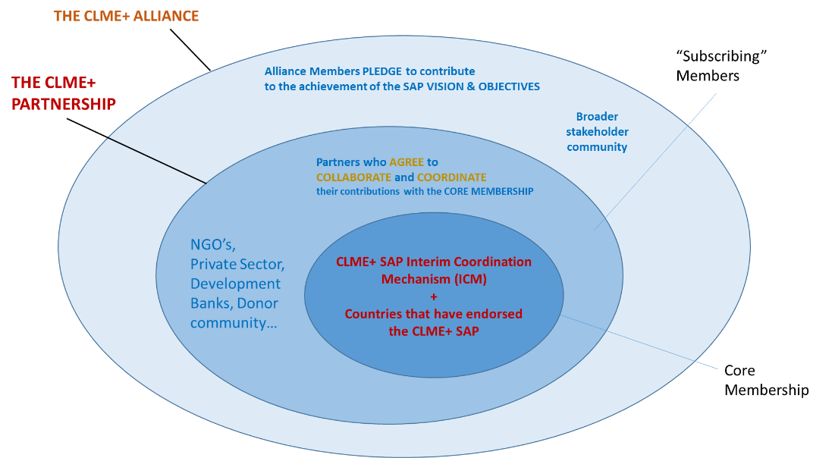

The CLME+ Partnership Core Membership consists of (a) the countries that have formally endorsed the CLME+ SAP, and (b) the Parties to the Memorandum of Understanding (MoU) that establishes and governs the “Interim Coordination Mechanism for the Sustainable Management, Use and Protection of shared Living Marine Resources in the Caribbean and North Brazil Shelf Large Marine Ecosystems”, further also referred to as the “CLME+ SAP Interim Coordination Mechanism”, “CLME+ SAP ICM”, or “ICM”.

Membership of the CLME+ Alliance is automatic for CLME+ Partnership members. CLME+ Alliance members subscribe to the long-term vision for the CLME+ region articulated under the 10-year CLME+ SAP and pledge to actively contribute to the improved health of the marine ecosystems of the region, and the sustainable management, use and protection of associated living resources.

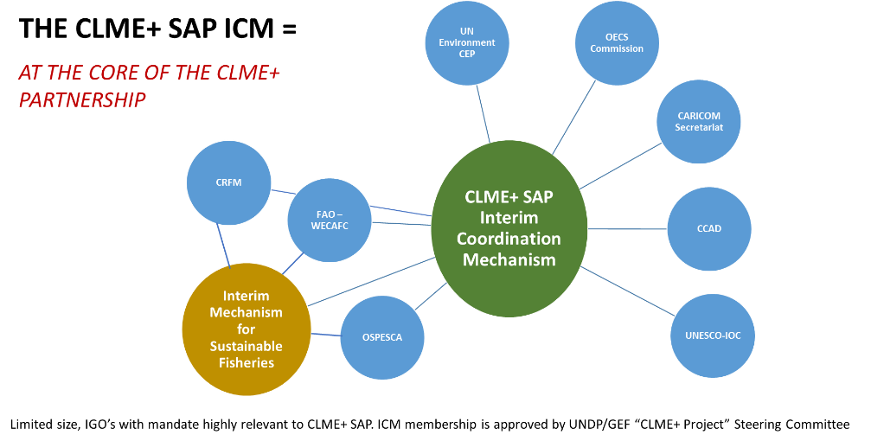
The CLME+ Partnership Coordinating Body and Secretariat

The basic composition of the CLME+ Partnership Coordinating Body will consist of the Membership of the CLME+ SAP ICM. The CLME+ SAP ICM may decide to invite a limited number of Subscribing Members to also become part of the Coordinating Body.

The Coordinating Body will facilitate the coordination of relevant activities of work on the Partnership and Alliance, in collaboration with the Secretariat.

The Coordinating Body will:

- periodically review and revise, as deemed relevant, the ToRs for the CLME+ Partnership;
- periodically review and revise, as deemed relevant, the Subscription and Acceptance mechanism for the CLME+ Partnership Membership;
- decide on the CLME+ Subscribing Partnership Membership;
- review and discuss matters of relevance to the CLME+ Partnership, at periodic meetings of the CLME+ SAP ICM;
- appoint the CLME+ Partnership Secretariat;
- delegate responsibilities to the Secretariat, as indicated below.

For the duration of the UNDP/GEF CLME+ Project, the role of Secretariat of the CLME+ Partnership (hereinafter further also referred to as the “Secretariat”) will be exercised by the Project Coordination Unit of the UNDP/GEF CLME+ Project. Following the finalization of the CLME+ Project, the CLME+ SAP ICM will decide on a new Secretariat.

The Secretariat will:

- manage the CLME+ Partnership Membership database;
- manage the Membership Subscription requests;
- ensure all relevant information, referred to under these ToRs, is available to the full Membership of the CLME+ Partnership.

Membership

The Secretariat, upon such request by the CLME+ SAP ICM will invite selected key stakeholders to become a Subscribing Member of the CLME+ Partnership.

Membership of the CLME+ Partnership will comprise interested and active stakeholders from within the CLME+ region and from around the Globe who:

- subscribe to, and commit to actively, consistently and substantially contribute to the achievement of the long-term Vision articulated under Item 5, in line with the Goal, Mission, Specific Objectives and Scope of the Partnership articulated under Items 6, 7, 8, 9 and 10;

- acknowledge in this context the need to embrace the concepts of, and support through their actions the adoption and implementation across the CLME+ region of:

Ecosystem-Based Management (EBM) and/or an Ecosystem Approach to Fisheries (EAF);

- acknowledge the importance of, and commit to adhere to and apply and/or promote, to the extent possible, the key guiding principles for good living marine resources management formulated under the 2015-2025 CLME+ SAP, and included in a format adapted to the CLME+ Partnership Membership under Item 13 of these ToRs;

- agree and commit to support and contribute, to the extent possible, to the implementation of CLME+ SAP Strategies and Priority Actions, and/or those of associated Programmes, Projects and Initiatives, based on and in alignment with their formal mandates, skills & experience and /or comparative advantages;

and

- agree and commit to communicate on and coordinate such action with relevant Members of the CLME+ Partnership, in particular relevant parties under the Core Membership.

The CLME+ Partnership Membership includes two types of Members:

the Core Membership:

- the CLME+ countries and territories that have politically endorsed the 2015-2025 CLME+ SAP or any future revisions or updates thereof, as applicable;
- the Parties to the MoU that establishes the CLME+ SAP ICM

Subscribing Members:

- other Members; these can include a wide range of stakeholders such as: Governments, (Inter-)Governmental Organizations and Entities, Universities, Research Centers, Educational Organizations, Civil institutions, Non-Governmental Organizations (NGO’s), UN agencies, Private Companies and Entities, Associations of Marine Resources Users, Donors, Development Partners and Development Banks, the Media, influential individuals, etc.

Membership cost:

No administrative cost is associated with the Membership

Subscription & Acceptance process:

Save in the case of the Core Members, who are members by default by virtue of either their endorsement of the CLME+ SAP or their participation in the CLME+ SAP ICM,
Membership of the CLME+ Partnership is formalized through the online registration by the prospective member of a pledge, called the “CLME+ Partnership Membership Pledge”, and the subsequent acceptance of this pledge by the Secretariat. For this purpose, the Secretariat will provide the prospective member with access to an online registration form.
.

Membership Renewal/Expiration:

Once every two years, at a date to be set by the Coordinating Body, the Secretariat will request Subscribing Members to confirm their continued engagement with the CLME+ Partnership. To this end, the Secretariat may request Members to fill in and submit a questionnaire, as proof of their continued commitment.

Upon such confirmation, and subject to the availability of proof of active commitment and engagement, the Member’s Membership will automatically be renewed.

Inactive memberships will expire at such time, and written communication of such expiration will be sent by the Secretariat to the concerned Member using the contact information provided by such Member in the Subscription Form, or any duly submitted modifications thereof. Expiration will become effective 2 months after such written notification has been given by the Secretariat.

Exit Clause / Withdrawal:

Countries and Subscribing Members can withdraw from the CLME+ Partnership at any time by giving three-months advance formal notice of such withdrawal to the Secretariat.

The withdrawal will become effective three months after the date of receipt by the Secretariat of such formal notice.

The Secretariat can, based on a consensus decision of the CLME+ SAP ICM, revoke and put to an end, either with immediate effect or by a given end date, the Membership of any Subscribing Member. To such end, the Secretariat will promptly give formal notice of such decision to the concerned Member.

In both cases, the Secretariat and the concerned Member will aim to agree on measures allowing for the orderly conclusion of on-going activities involving the Member and the Core Membership.

Guiding Principles for good marine resources governance and management

The CLME+ Partnership brings together stakeholders with a common desire to promote, enable and ensure the sustainable management of the shared living marine resources and biodiversity of the CLME+ region, willing to take a role and responsibility in conserving the global value and associated regional benefits of these resources.
While recognizing that (a) the below principles have already been previously adopted by some Members; and (b) that these should now be further promoted; Members will consider and take into account, where appropriate, the below key principles of good (living marine resources) management described in Annex 1 to the 2015-2025 CLME+ SAP, considered to be fully applicable to the SAP endorsing Parties and herewith by extension, in the below format adapted to the wider range of stakeholders under the CLME+ Partnership, to each [Subscribing] Member:

- An ecosystem-based approach [to fisheries management] should be applied, which maintains key characteristics of ecosystems in a way that sustains species and ecological processes while supporting human use for economic or social purposes.
- The principle of sustainable development should be applied such that there is a prudent and rational utilization of living resources and the preservation of the rights of future generations to a viable environment.
- The principle of adaptive management should be applied such that there is a systematic, rigorous approach for deliberately learning from management actions with the intent to improve subsequent management policy or practice.
- The principles of good governance should be applied, including participation, the rule of law, transparency, accountability, responsiveness, consensus building, equity, effectiveness and efficiency.
- The principle of subsidiarity should be applied.
- Risk management should be applied:
  - A precautionary approach should be applied, such that measures shall be taken when there are reasonable grounds for concern that any activity may increase the potential hazards to human health, harm living resources or ecosystems, damage amenities, or interfere with other legitimate uses of the Caribbean and North Brazil Shelf Large Marine Ecosystems, even when there is no conclusive evidence of a causal relationship between the activity and the effects; and by virtue of which, greater caution is required when information, including scientific information, is uncertain, unreliable or inadequate.
  - The principle of anticipatory action should be applied, such that contingency planning, environmental impact assessment and strategic impact assessment (involving the assessment of the environmental and social consequences of policies, programmes and plans) shall be undertaken in the future development in the region.
  - The principle of preventive action should be applied, such that timely action shall be taken to alert the responsible and relevant authorities of likely impacts and to address the actual or potential causes of adverse impacts on the environment, before they occur.
- The following criteria should be mainstreamed in the development of all relevant policies, programmes, plans and actions: (i) solutions must increase the resilience of societies and ecosystems to climate change; and (ii) solutions must be robust in the context of the uncertainty associated to climate change.
- The principles of public participation and transparency should be applied, such that all stakeholders, including communities, individuals and concerned organisations shall be given the opportunity to participate, at the appropriate level, in decision-making and management processes that affect the marine environment of the CLME⁺ region This includes providing access to information concerning the environment that is held by public authorities, together with effective access to judicial and administrative proceedings to enable all stakeholders to exercise their rights effectively. Public authorities shall widely disseminate information on the work proposed and undertaken to monitor, protect and improve the state of the marine environment of the CLME⁺ region

Partnership Operational Principles

Members acknowledge that being a Member of the CLME+ Partnership does not constitute a formal individual partnership with any other Member of the CLME+ Partnership or allows the Member to represent such other Member(s) under any circumstance other than explicit written authorization from the Member(s) concerned. Neither does it imply that the Member may claim to have an advantage position to influence any decision(s) to be taken in the framework of the CLME+ Partnership.
Acceptance as a Member by the Secretariat does not constitute a de facto endorsement by the Secretariat or any other Member, of any of the actions, statements and declarations undertaken by such Member, either within or outside of the context of activities undertaken under the umbrella of the CLME+ Partnership.
Neither the Secretariat nor any employee, subcontractor, agent or assignee of the Secretariat, nor any of the other CLME+ Partnership Members, their employees, subcontrators, agents or assignees, other than the Subscribing Member, will be liable for any direct, indirect, incidental, special, or consequential damage of any kind whatsoever (including, without limitation, attorney’s fees and lost profits or savings) in any way due to, resulting from, or arising in connection with the participation of the Member in the CLME+ Partnership.
Any action of coordination, cooperation or collaboration that takes place under the umbrella of the CLME+ Partnership will be subject to the availability of resources to support such action. Financial arrangements can be described among Members through separate written agreements to that effect.

- Partnership Visibility & Branding

Members agree to explicitly acknowledge the role and contribution(s) of each Member as well as of the Secretariat and its associated supporting entities, as applicable, in any coordination and/or collaborative effort, and in any public documentation or product, emanating from their collaboration under the umbrella of the CLME+ Partnership.

In doing so, Members agree to adhere to, in the best possible extent, applicable policies and visibility & branding guidelines, in particular (but not limited to) those established for the CLME+ Partnership by the Secretariat and approved by the Core Membership, and any periodic, formally approved revisions thereof.

The Members agree not to use in any press release, memo, report, or other published disclosure related to the CLME+ Partnership the name(s) or logo(s) of any of the other Members without the prior consent of the concerned Partner(s).

Duration of the CLME+ Partnership

The CLME+ Partnership is formally established on (insert start date) as per the consensus decision of (insert start date) of the CLME+ SAP ICM.

In alignment with its Goal, described under Item 6, the CLME+ Partnership is intended to be a long-term partnership arrangement. It will remain in existence until terminated by a decision of the CLME+ SAP ICM.

- Entry into Effect and Amendments to the Terms of Reference

These Terms of Reference (ToRs) enter into effect on the date of their endorsement by the CLME+ SAP ICM.

The ToRs may only be amended by a consensus decision of the ICM.

In case of such amendments, each CLME+ Partnership Member will be notified and given access to the amended ToRs. The amended ToRs will become effective four months after the date on which all Members have been formally notified of such amendment(s).

Complementary Agreements

While procuring to ensure full consistency with the present ToRs, these umbrella ToRs may be complemented with additional written agreements between any individual Subscribing Member and the Secretariat, the Core Membership or any of its individual Members, with the aim of (a) further identifying areas of mutual interest and (b) agreeing on more specific fields for coordination and collaborative action(s), as well as on any additional principles and procedures governing such action(s).

ENDORSEMENT OF THE TERMS OF REFERENCE

These ToRs have been endorsed on ……………………… by consensus decision of the CLME+ SAP ICM, thereby formally establishing the “GLOBAL PARTNERSHIP FOR THE SUSTAINABLE MANAGEMENT, USE AND PROTECTION OF THE CARIBBEAN AND NORTH BRAZIL SHELF LARGE MARINE ECOSYSTEMS” (“CLME+ PARTNERSHIP”).

The UNDP/GEF “CLME Project” (2009-2014) was a foundational capacity building project for the countries of the CLME+ region, executed by UNOPS in a co-executing arrangement with several UN sister organizations and governmental and non-governmental organizations native to the CLME+ region.
Date of endorsement of this document by the CLME+ SAP Interim Coordination Mechanism
including the formulation and application of principles guiding those interactions and care for the institutions that enable and control them
The UNDP/GEF “CLME+ Project” (2015-2020), executed by UNOPS in a co-executing arrangement with UN sister organizations and governmental and non-governmental organizations native to the CLME+ region, aims at catalysing the implementation of the CLME+ SAP.
E.g.: (a) factors external to the CLME+ region with an impact on the region and its marine resources; (b) considerations of economies of scale;…
The CLME+ SAP ICM is a limited grouping of Inter-Governmental Organizations with a formal mandate on the marine environment of the CLME+ region. It was established through and is regulated by a Memorandum of Understanding (MoU) signed among its Parties. At its inception in June 2017, the CLME+ SAP ICM was composed of: UN Environment CEP, FAO-WECAFC, IOC of UNESCO, OSPESCA, CCAD, CRFM, CARICOM Secretariat, OECS.
For this purpose, decision-making principles and rules will be inherited from the CLME+ SAP ICM, and extend to all Coordinating Body Members.

